**IoT PATIENT VITALS MONITORING SYSTEM**

**Group Members**

1.Priscilla Bedzra

2.Angela De-Santo

3.Joshua Lartey

4.Roland Ashiteye

TABLE OF CONTENT

1. Introduction ……………………………………………………………………………………………
   1. Scope……………………………………………………………………………………………………….
   2. List of Definitions……………………………………………………………………………………..
   3. References………………………………………………………………………………………………..
   4. Overview…………………………………………………………………………………………………..
2. General Description…………………………………………………………………………………..
   1. Main Goal………………………………………………………………………………………………….
   2. General Capabilities…………………………………………………………………………………..
   3. General Constraints…………………………………………………………………………………...
   4. User Characteristics…………………………………………………………………………………..
3. User Profile………………………………………………………………………………………………
   1. Persona 1…………………………………………………………………………………………………..
4. Constraints…………………………………………………………………………………………………
5. Actual Requirements………………………………………………………………………………….

Chapter1- Introduction

1.1 Purpose

The purpose of this document is to present a detailed description of the IoT Patient Vitals Monitoring System Web Application, explain the purpose and features of the web application, the interfaces of the web app, what the web app will do, the constraints under which it must operate and how the website will react with users. This document is intended for both the stakeholders and the developers of the system.

1.2 Scope

The project is a web app which will enable health workers to input the records of patients’ vitals, specifically, the temperature, respiration and pulse of the patients. The web app will be designed to display a graph of these vitals to help determine how normal or abnormal a particular patient’s vitals are. The web app will be designed to meet the user’s needs while remaining easy to understand and use.

1.3 List of definitions

User: Someone who will be assessing the web app.

Stakeholder: Any person with an interest in the project who is not a developer.

Developer: Any person who develops an app and is not the user or the publisher.

1.4 References

[www.bootstrap.com](http://www.bootstrap.com)

[www.youtube.com](http://www.youtube.com)

[www.google.com](http://www.google.com)

[www.github.com](http://www.github.com)

[www.trello.com](http://www.trello.com)

1.5 Overview

This document contains all of the web app requirement specifics. It contains a general description of the types of users who will be using our web app, how it is going to work, and what technologies we are using to make it work. We will outline the components of the project.

CHAPTER TWO

General Description

2.1 Main Goal

The web app will offer users with a user-friendly interface that provides users with easy to use and understand features that enable them to compute patient vitals recordings easily with minimum hindrance.

2.2 General Capabilities

Our group’s aim is to build a responsive web app which will provide users with an interface, simple to use and understand.

2.3 General Constraints

The running of the web application is constrained by the user’s input. That is, the user has to input data for the application to serve its purpose.

2.4 User Characteristics

***Web application user***: The web app user can login and register into the system in order to access the web app. The web app user can also record the patient’s vitals and view the graph of these vitals as well.

***Web application Administrator***: The web app administrator will manage the web app and provide explicit opinions to users in the forum section of the web app.

CHAPTER THREE

User Profile

In a world where technology is fast advancing, it has become essential to input and store data digitally than manually. In this regard, space, time and efforts are used efficiently, and also these records are secured from intrusion.

The potential users of our web app are;

* Nurses
* Doctors.

3.1 Persona 1

***Name:*** Angela

***Background***: Angela is a nurse at the University of Cape Coast hospital and always has to request for her patients’ hospital folder before she can record her patients vitals. It usually takes time and sometimes gets frustrating. She is also concerned about the low security for these folders since it is just a book that anyone can actually grab and get hold of this sensitive information. It can also be affected by natural disasters like flood or fire.

***Need***: Angela needs a computer with a web app that can help her record her patients’ vitals faster and more efficiently. She also needs a more secured way of keeping the records of her patients.

CHAPTER FOUR

Constraints

Records of patients’ vitals should be recorded in order for the web app to work.

CHAPTER FIVE

Actual Requirements

* Users should be able to register.
* The user should be able to login after registering.
* The user should be able to input the patients’ vitals record.
* The system should be able to see a drawn a graph of the vitals.

**CLASS DIAGRAM**

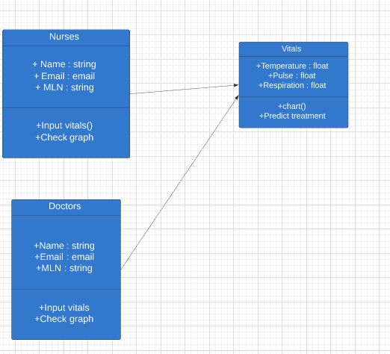

**USE CASE DIAGRAM**

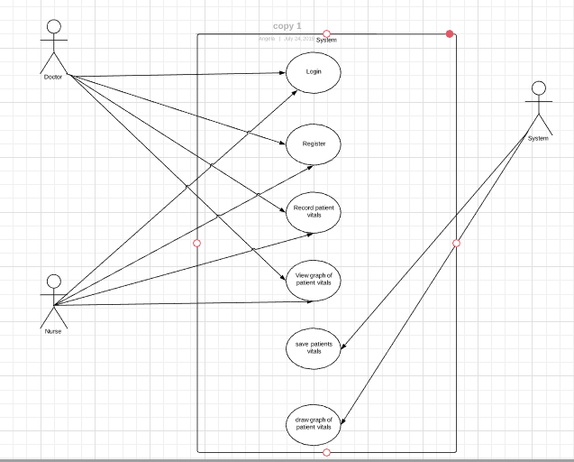

INSTALLATION GUIDE

1. Quick installation

* Git the project from <https://github.com/larteyjoshua/IoT-Patient-Vitals-Monitoring-System>
* Extract the folder using 7zip
* Install requirements:

1. pip install -r 'requirements.txt' to install the requirements
2. Run the application: python app.py